SIMATS ENGINEERING
ASSESSMENT TOOL 1 – Medium (Scenario Based Assessment)
COURSE CODE: CSA09 COURSE NAME: Programming in Java
COURSE OUTCOME COVERED
CO2: Implement Collection Framework interfaces such as List, ArrayList, Set, Map, HashTable, and HashMap using iterators and generics to store, retrieve, and process groups of objects in web applications.(BL3,BL4)

QUESTIONS: 5 Total Marks: 100
ANNEXURE A
Scenario Based Assessment
Code of Conduct:

I B.ANJALI(192371062) (Name / Reg No) certify that this submission is my original work and that I have adhered to the guidelines specified for this assessment.
I understand that any violation of academic integrity rules will result in disciplinary action.

Signature of the student:B.ANJALI

RUBRICS FOR CALCULATION:

Criteria | Level 4 – Exemplary | Level 3 – Proficient | Level 2 – Developing | Level 1 – Beginning
Problem Understanding & Context Analysis
Application of Concepts
Analytical & Decision-Making Skills
Solution Design & Approach
Clarity, Justification & Presentation

ANNEXURE
Scenario Based Assessment
Q1: Student Registration System
Suppose that a university system stores student data, where each student must be unique and can enroll in multiple courses.
(a) Enumerate three Collection interfaces suitable for this system.
(b) Design a Collection structure (diagram/representation) to store students and their enrolled courses.
(c) Write a Java program using HashSet and HashMap with Generics to:
• Add students
• Map students to courses
• Display data using Iterator

Q1. Student Registration System
(a) Three Collection interfaces suitable for this system
- Set – Used to store unique students because duplicate students are not allowed.
- Map – Used to map each student to their enrolled courses.
- List – Used to store multiple courses for a student in an ordered manner.
(b) Collection structure
Student Registration System
|
HashSet<Student>
|
-------------------------
| | |
Student1 Student2 Student3
| | |
HashMap<Student, List<Course>>
|
----------------
| |
Student1 Student2
| |
-------------- ------------
| | | | |
Java DBMS OS Java Python
Representation:
HashSet<Student>
↓
Unique Students

HashMap<Student, List<String>>
↓
Student → Courses

(c) Java Program using HashSet and HashMap with Generics
import java.util.*;

public class Main {
public static void main(String[] args) {

HashSet<String> students = new HashSet<>();

students.add("Anjali");
students.add("Rahul");
students.add("Priya");

HashMap<String, String> courses = new HashMap<>();

courses.put("Anjali", "Java, DBMS");
courses.put("Rahul", "Python, AI");
courses.put("Priya", "Java, Cloud");

System.out.println("Students:");

Iterator<String> studentIterator = students.iterator();

while (studentIterator.hasNext()) {
String student = studentIterator.next();
System.out.println(student);
}

System.out.println("\nStudent Courses:");

Iterator<Map.Entry<String, String>> iterator =
courses.entrySet().iterator();

while (iterator.hasNext()) {
Map.Entry<String, String> entry = iterator.next();
System.out.println(entry.getKey() + " -> " + entry.getValue());
}
}
}

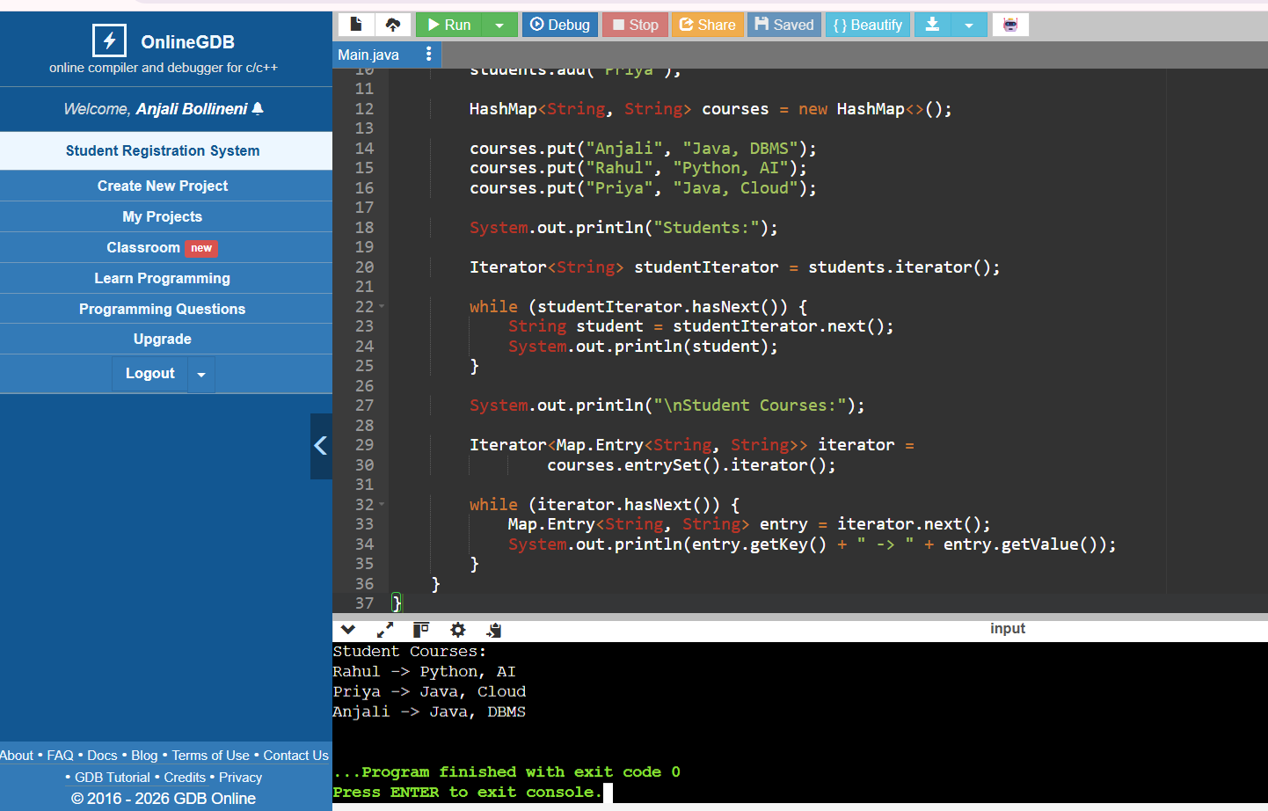
Justification
HashSet ensures that each student is unique. HashMap stores the relationship between a student and their courses. Generics provide type safety, while Iterator is used to traverse the collections.

Q2: E-Commerce Cart System
Suppose that an online shopping system maintains a cart where products are added, removed, and displayed in order.
(a) List three Collection classes applicable for cart management.
(b) Represent how cart items are stored using a List-based structure.
(c) Write a Java program using ArrayList and Iterator to:
• Add items
• Remove an item
• Display all items
Q2. E-Commerce Cart System
(a) Three Collection classes applicable
- ArrayList – Stores cart items in insertion order.
- LinkedList – Suitable when frequent insertion and deletion are required.
- Vector – Stores elements dynamically and maintains insertion order.
(b) List-based structure
Shopping Cart
|
ArrayList
|
-------------------------
| | | |
Laptop Mouse Keyboard Bag
0 1 2 3
A List allows duplicate products and maintains the order in which items are added.

(c) Java Program using ArrayList and Iterator
import java.util.*;

public class Main {
public static void main(String[] args) {

ArrayList<String> cart = new ArrayList<>();

cart.add("Laptop");
cart.add("Mouse");
cart.add("Keyboard");
cart.add("Headphones");

cart.remove("Mouse");

System.out.println("Cart Items:");

Iterator<String> iterator = cart.iterator();

while (iterator.hasNext()) {
System.out.println(iterator.next());
}
}
}
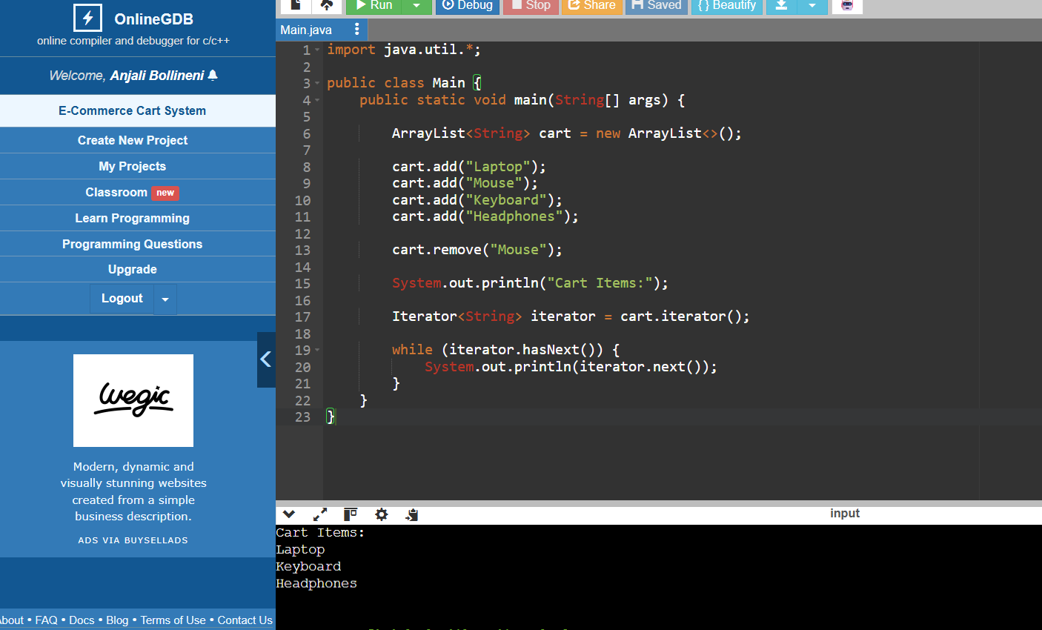
Output
Cart Items:
Laptop
Keyboard
Headphones
Justification
ArrayList is suitable because it maintains insertion order and allows easy access to elements. Iterator is used to safely traverse and display the cart items.

Q3: Library Management System

Suppose that a library stores books with unique ISBN numbers and needs fast retrieval.
(a) Name three Map implementations in Java.
(b) Design a schema-like representation using Map for storing ISBN and book details.
(c) Write a Java program using HashMap to:
• Insert book details
• Retrieve a book
• Display all books
Q3. Library Management System
(a) Three Map implementations in Java
- HashMap – Stores key-value pairs and provides fast retrieval.
- LinkedHashMap – Maintains insertion order.
- TreeMap – Stores entries in sorted order of keys.
(b) Schema-like representation
Library
|
HashMap
|
ISBN → Book Details
|
----------------------
| | |
978001 978002 978003
| | |
Java Book DBMS Book Python Book
Example:
ISBN Book Details
-----------------------------------
978001 Java Programming
978002 Database Systems
978003 Python Basics
Here, ISBN is the key and book details are the values.

(c) Java Program using HashMap
import java.util.*;

public class Main {
public static void main(String[] args) {

HashMap<String, String> books = new HashMap<>();

books.put("978001", "Java Programming");
books.put("978002", "Database Systems");
books.put("978003", "Python Basics");

System.out.println("Retrieved Book:");
System.out.println(books.get("978002"));

System.out.println("\nAll Books:");

Iterator<Map.Entry<String, String>> iterator =
books.entrySet().iterator();

while (iterator.hasNext()) {
Map.Entry<String, String> entry = iterator.next();

System.out.println(entry.getKey() + " -> " + entry.getValue());
}
}
}
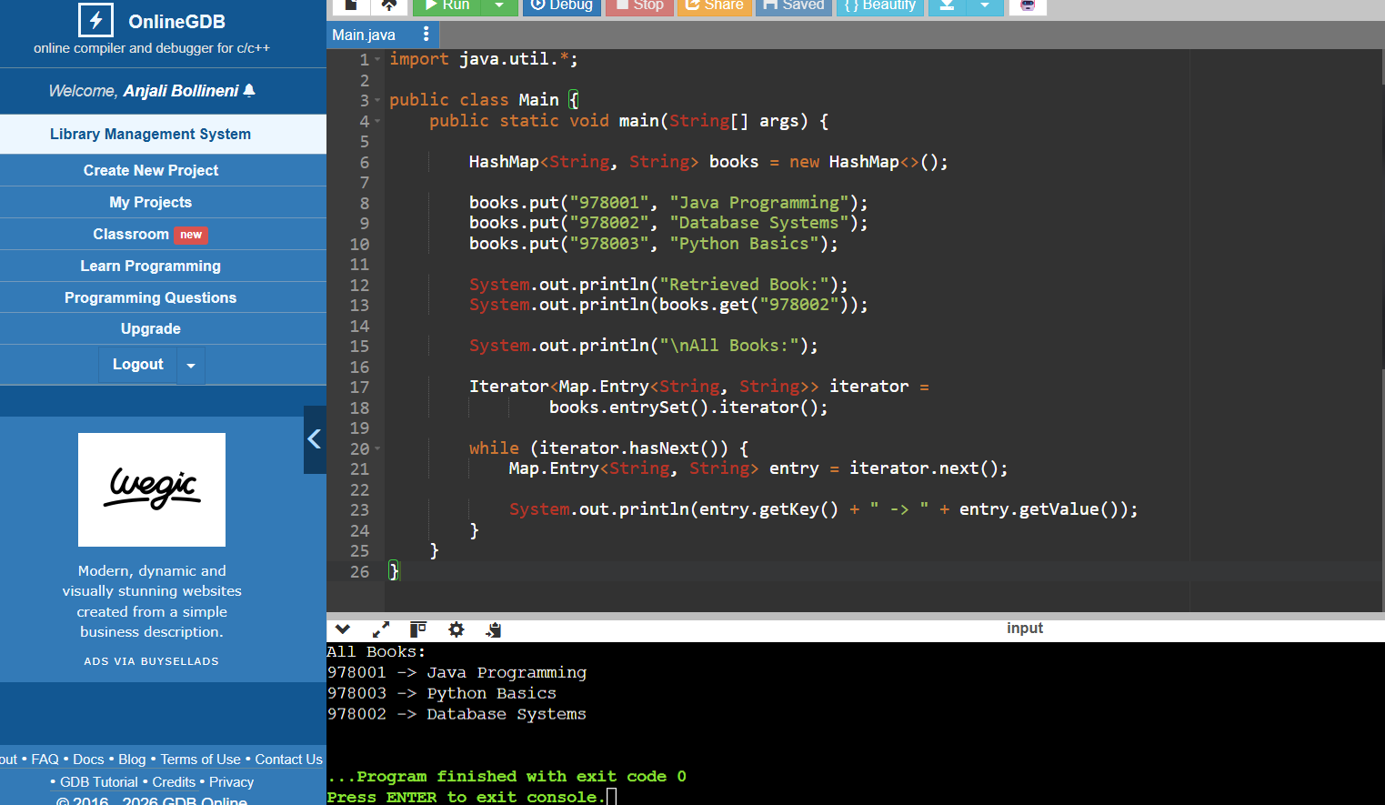
Output
Retrieved Book:
Database Systems

All Books:
978001 -> Java Programming
978002 -> Database Systems
978003 -> Python Basics
Justification
HashMap is appropriate because ISBN numbers are unique and can be used as keys. It provides efficient retrieval of book details using the ISBN.

Q4: Employee Data Processing
Suppose that a company processes employee records and filters employees based on salary.
(a) List three advantages of Generics in Collections.
(b) Represent how employee data is stored using List with Generics.
(c) Write a Java program using Iterator to:
• Store employee objects
• Display employees with salary > 50,000
Q4. Employee Data Processing
(a) Three advantages of Generics in Collections
- Type Safety – Generics allow only the specified type of objects to be stored.
- No Explicit Type Casting – Objects can be retrieved without manually casting them.
- Compile-Time Error Checking – Incorrect data types are detected during compilation.
(b) Employee data using List with Generics
List<Employee>
|
---------------------
| | |
Employee1 Employee2 Employee3
| | |
ID,Name, ID,Name, ID,Name,
Salary Salary Salary
Example:
List<Employee>
↓
[Employee(101, Anjali, 60000),
Employee(102, Rahul, 45000),
Employee(103, Priya, 70000)]

(c) Java Program using Iterator
import java.util.*;

class Employee {
int id;
String name;
double salary;

Employee(int id, String name, double salary) {
this.id = id;
this.name = name;
this.salary = salary;
}
}

public class Main {
public static void main(String[] args) {

List<Employee> employees = new ArrayList<>();

employees.add(new Employee(101, "Anjali", 60000));
employees.add(new Employee(102, "Rahul", 45000));
employees.add(new Employee(103, "Priya", 70000));

Iterator<Employee> iterator = employees.iterator();

System.out.println("Employees with salary above 50000:");

while (iterator.hasNext()) {
Employee e = iterator.next();

if (e.salary > 50000) {
System.out.println(
e.id + " " + e.name + " " + e.salary
);
}
}
}
}
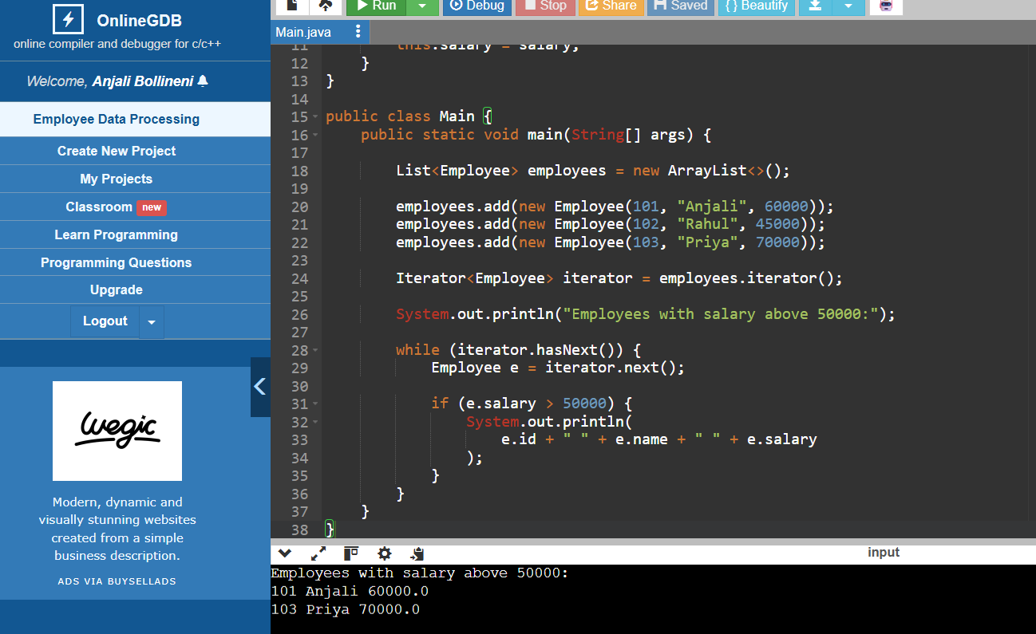
Output
Employees with salary above 50000:
101 Anjali 60000.0
103 Priya 70000.0
Justification
List<Employee> stores only Employee objects because of Generics. The Iterator traverses each employee, and the if condition filters employees whose salary is greater than ₹50,000.

Q5: Online Voting System

Suppose that an online voting system ensures one vote per user and counts votes efficiently.
(a) Identify three suitable Collection types for this system.
(b) Design a structure using Set and Map for voters and vote counting.
(c) Write a Java program using HashSet and HashMap to:
• Record votes
• Prevent duplicate voting
• Display results
Q5. Online Voting System
(a) Three suitable Collection types
- HashSet – Stores unique voter IDs and prevents duplicate voting.
- HashMap – Stores candidates and their vote counts.
- List – Can store candidate names or voting information when ordered storage is needed.
(b) Structure using Set and Map
Online Voting System
|
-------------------------
| |
HashSet<Voter> HashMap<Candidate,Integer>
| |
Unique Voters Vote Counts
| |
---------------- -------------
| | | | |
V101 V102 V103 Anjali Rahul
2 votes 1 vote
Example:
HashSet
--------
V101
V102
V103

HashMap
--------
Anjali → 2
Rahul → 1
Priya → 0
(c) Java Program using HashSet and HashMap
import java.util.*;

public class Main {
public static void main(String[] args) {

HashSet<String> voters = new HashSet<>();

HashMap<String, Integer> votes = new HashMap<>();

votes.put("Anjali", 0);
votes.put("Rahul", 0);
votes.put("Priya", 0);

recordVote("V101", "Anjali", voters, votes);
recordVote("V102", "Rahul", voters, votes);
recordVote("V103", "Anjali", voters, votes);

// Duplicate vote
recordVote("V101", "Priya", voters, votes);

System.out.println("\nVoting Results:");

Iterator<Map.Entry<String, Integer>> iterator =
votes.entrySet().iterator();

while (iterator.hasNext()) {
Map.Entry<String, Integer> entry = iterator.next();

System.out.println(
entry.getKey() + " -> " + entry.getValue() + " votes"
);
}
}

static void recordVote(String voter, String candidate,
HashSet<String> voters,
HashMap<String, Integer> votes) {

if (voters.contains(voter)) {
System.out.println(
"Duplicate vote rejected for voter: " + voter
);
} else {
voters.add(voter);
votes.put(candidate, votes.get(candidate) + 1);

System.out.println(
"Vote recorded for " + candidate
);
}
}
}
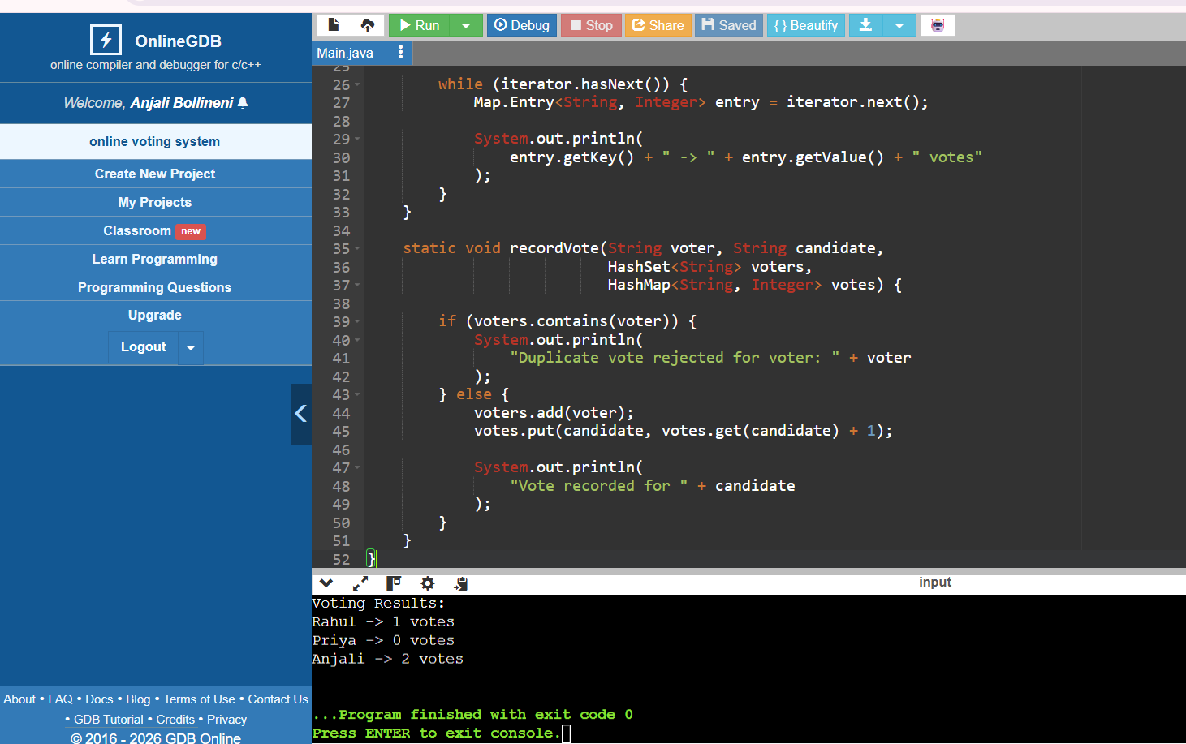
Output
Vote recorded for Anjali
Vote recorded for Rahul
Vote recorded for Anjali
Duplicate vote rejected for voter: V101

Voting Results:
Anjali -> 2 votes
Rahul -> 1 votes
Priya -> 0 votes
Justification
HashSet prevents a voter from voting more than once because duplicate voter IDs cannot be stored. HashMap efficiently maintains the number of votes received by each candidate. Iterator is used to display the final results.

Quick revision table

Question | Main Collection | Purpose
Q1Student Registration | HashSet, HashMap | Unique students and course mapping
Q2 E-Commerce Cart | ArrayList | Ordered cart items
Q3 Library | HashMap | ISBN-based fast retrieval
Q4 Employee | List<Employee> | Store and filter employees
Q5 Voting | HashSet, HashMap | Prevent duplicate votes and count votes

